ASSIGNMENT 1

1. Write a C# Sharp program that takes three letters as input and display

them in reverse order.

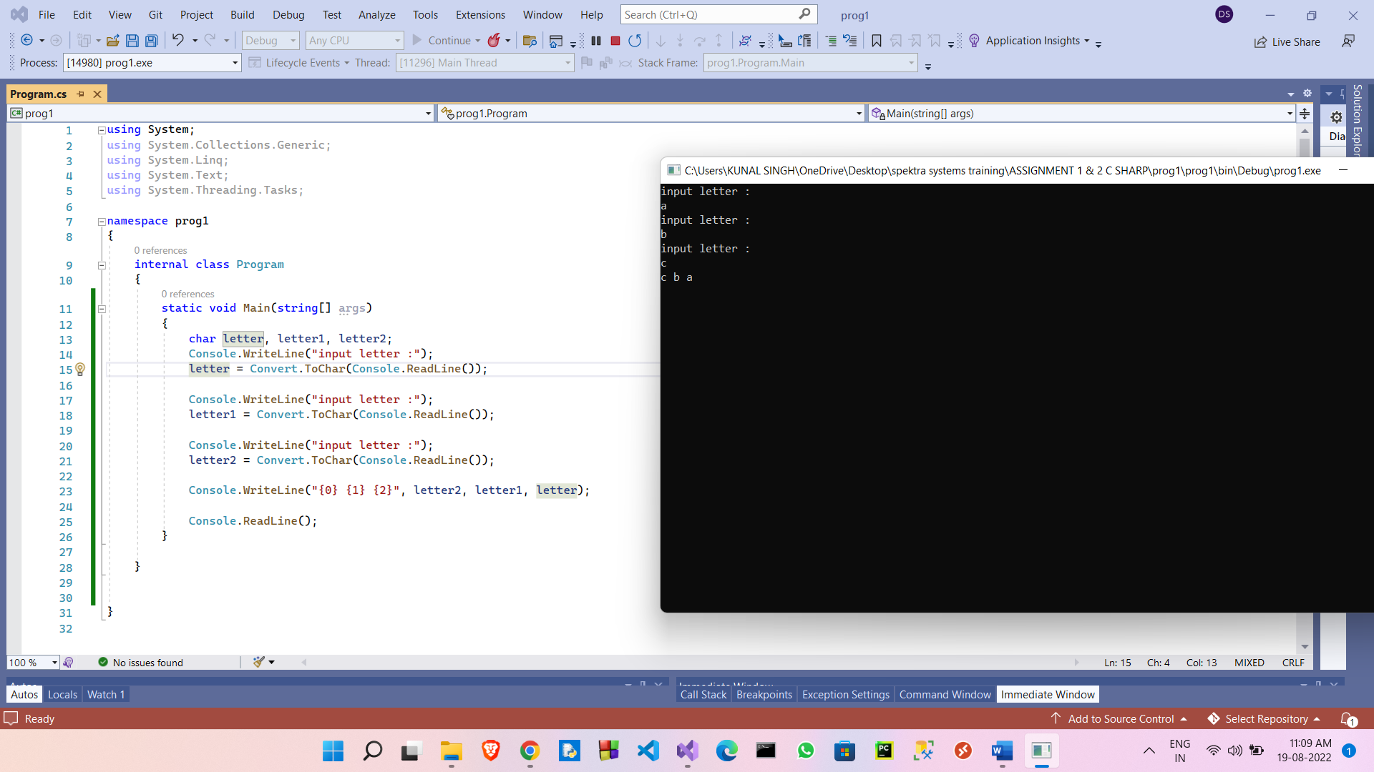

1. Write a C# Sharp program that takes a number and a width also a number, as input and then displays a triangle of that width, using that number.

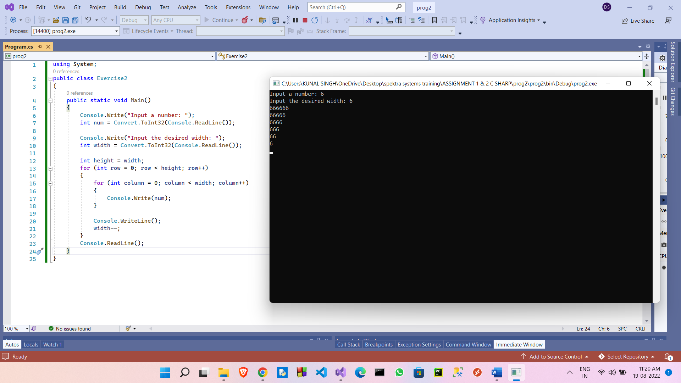

1. Write a C# Sharp program that takes userid and password as input (type string). After 3 wrong attempts, user will be rejected.(Store user data in hashtable/Dictionary)

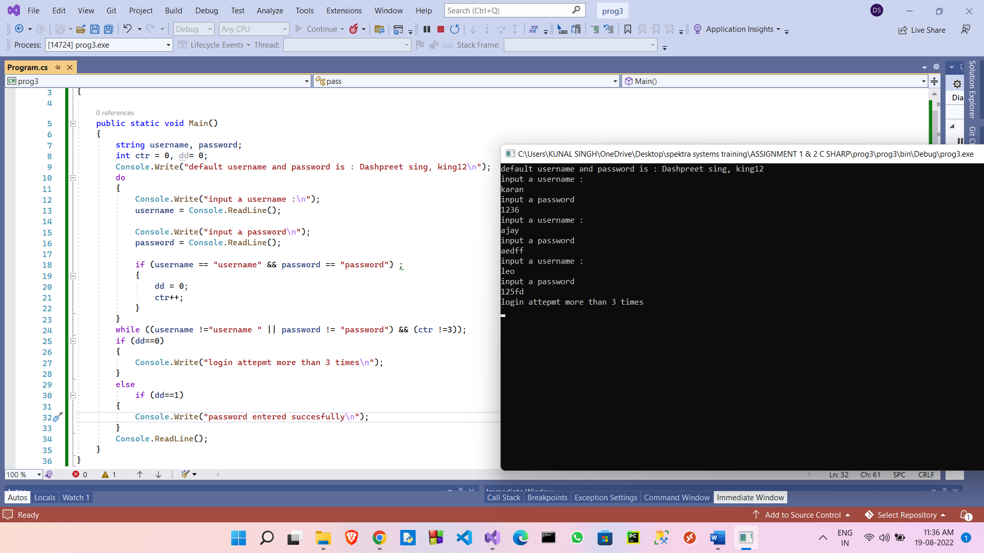

1. Write a C# Sharp program that takes two numbers as input and perform an operation (+,-,*,x,/) on them and displays the result of that operation

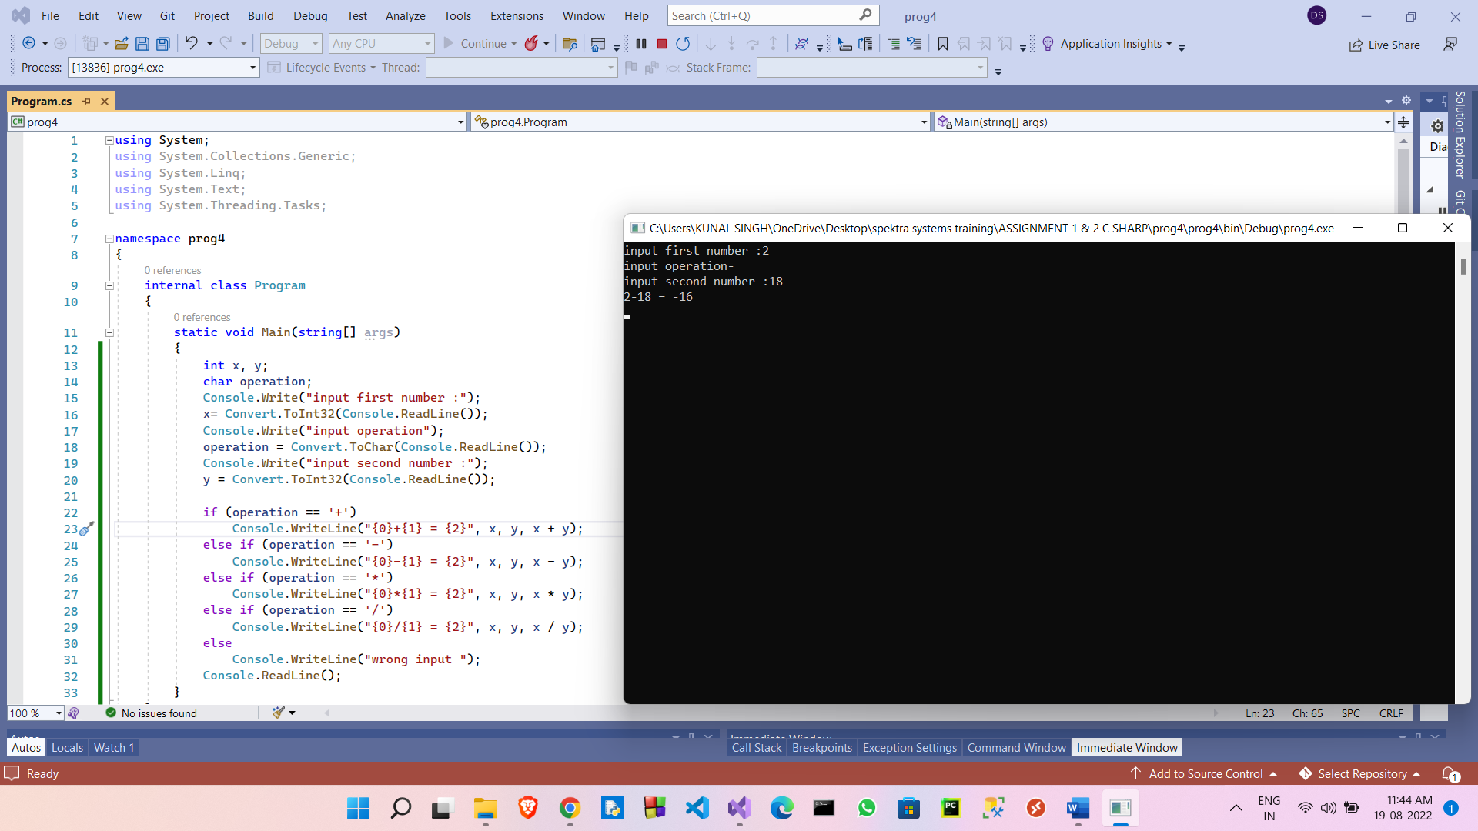

1. Write a C# Sharp program that takes the radius of a circle as input and calculate the perimeter and area of the circle.

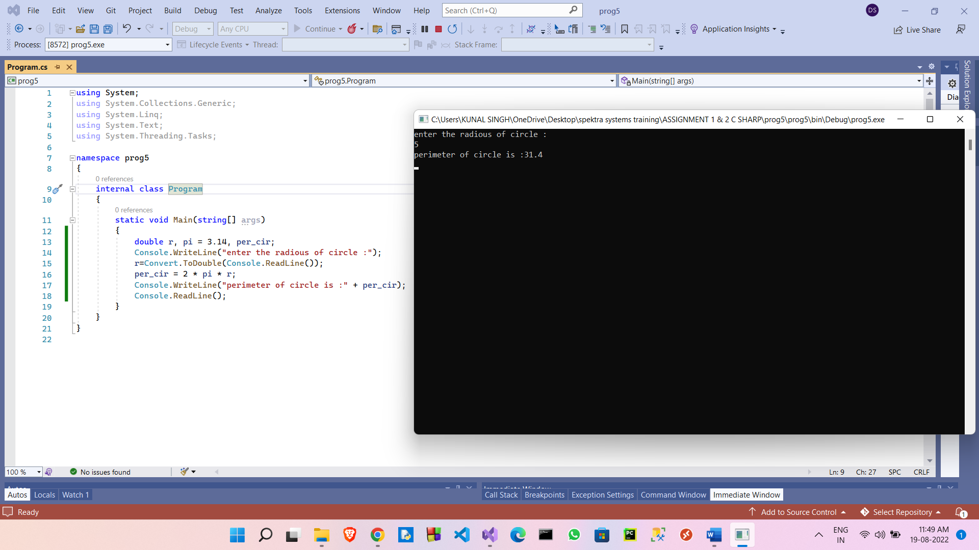

1. Write a C# Sharp program that takes distance and time as input and displays the speed in kilometres per hour and miles per hour.

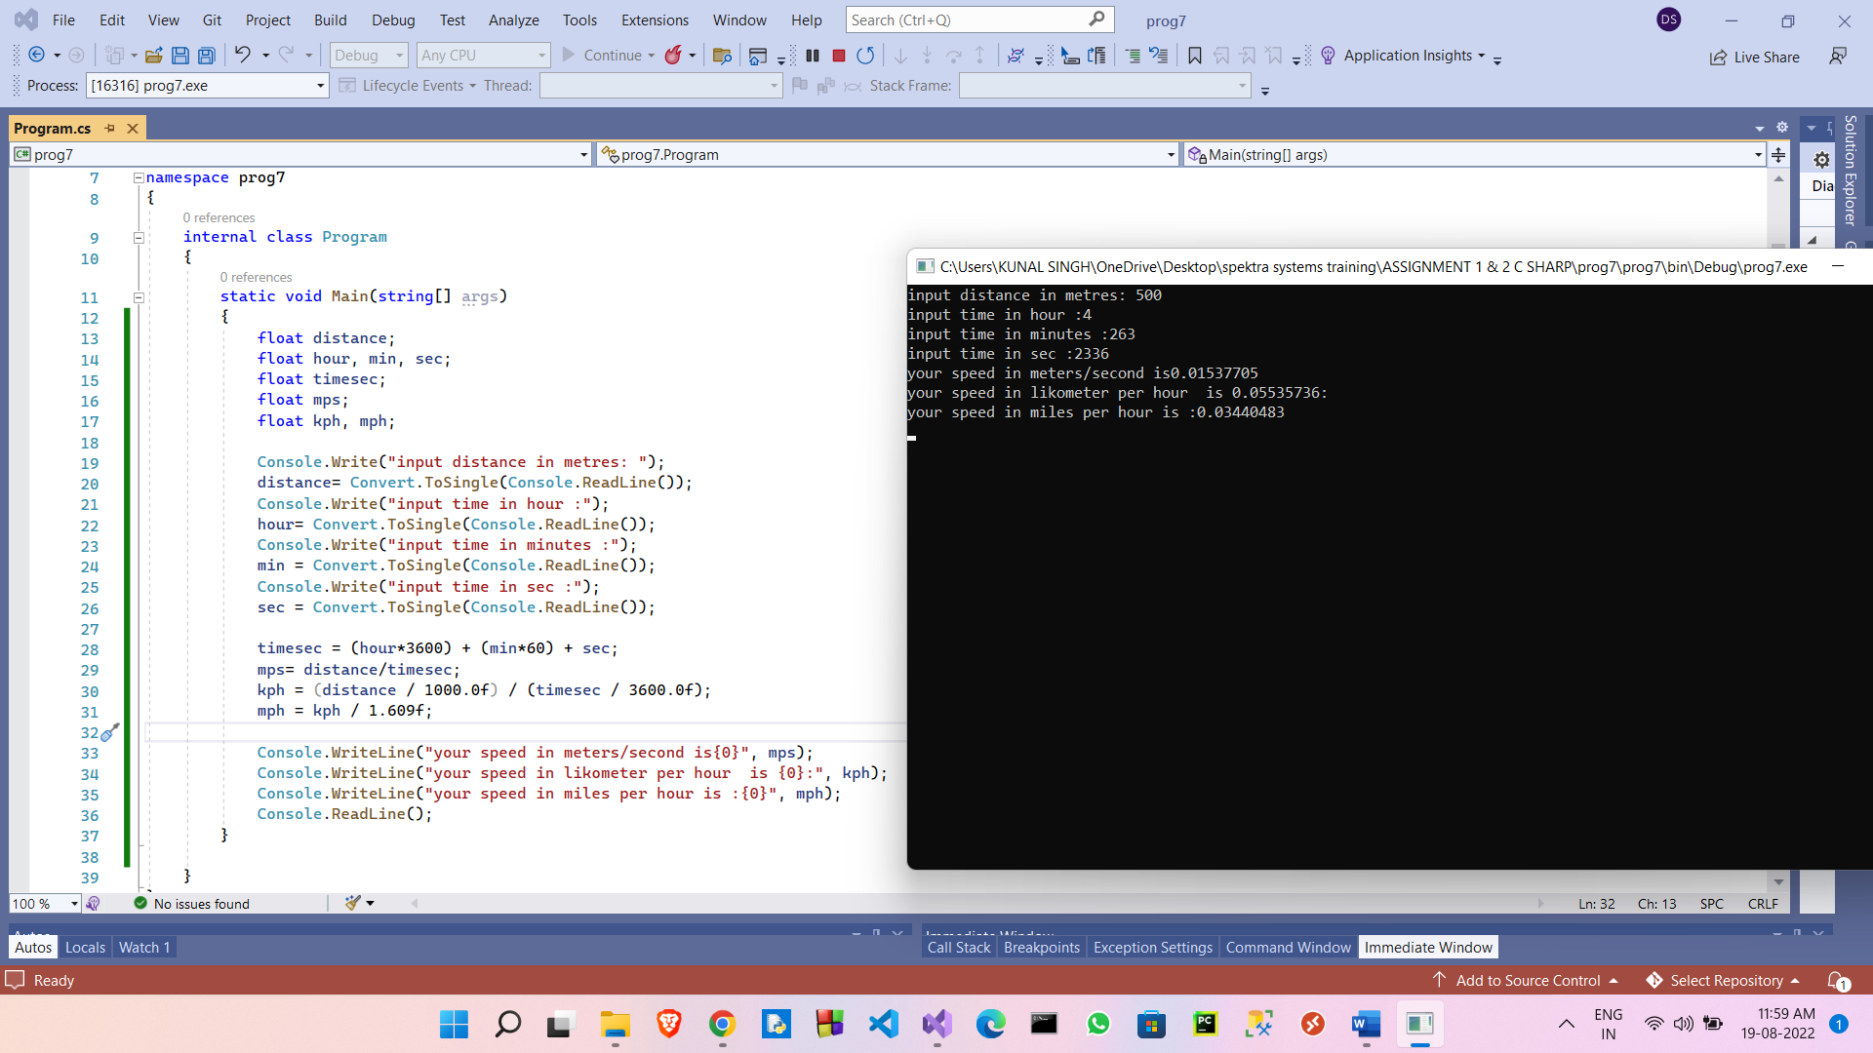

1. Write a C# Sharp program that takes a character as input and check the input (lowercase) is a vowel, a digit, or any other symbol.

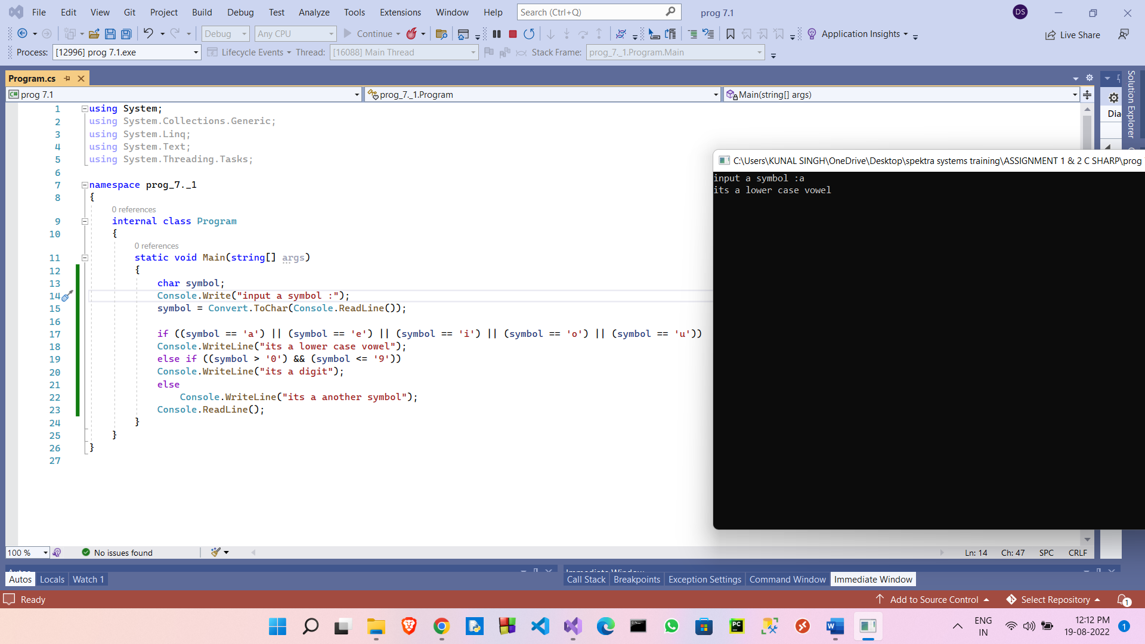

1. Write a C# Sharp program that takes two numbers as input and returns true or false when both numbers are even or odd.

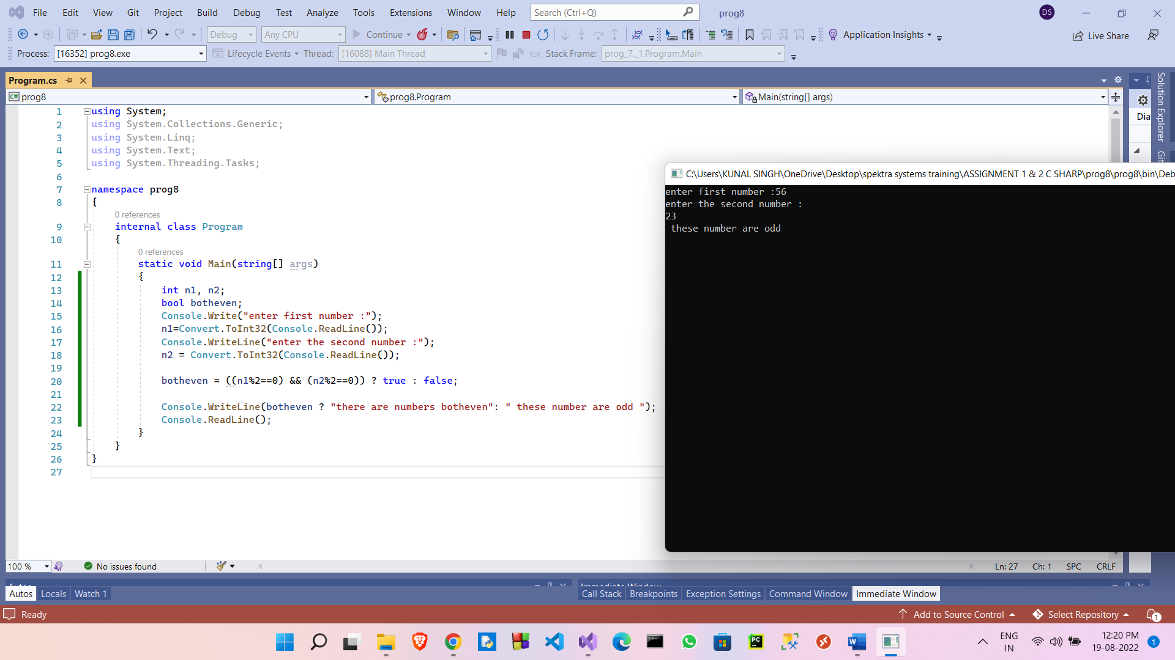

1. Write a C# Sharp program that takes a decimal number as input and displays its equivalent in binary form.

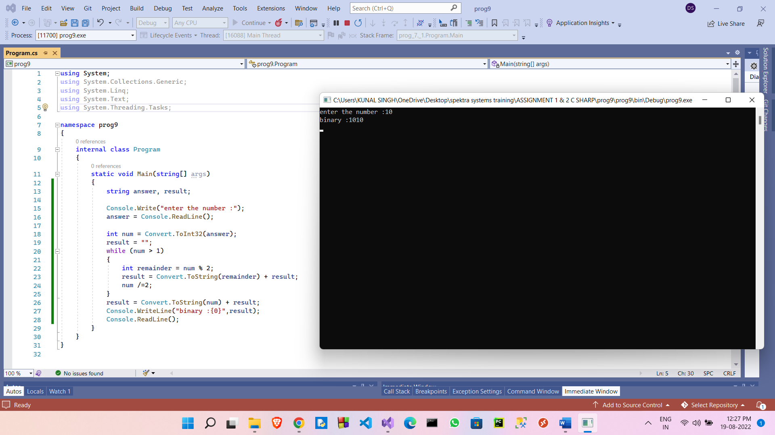

1. Write a C# Sharp program to get the absolute difference between n and 51. If n is greater than 51 return triple the absolute difference.

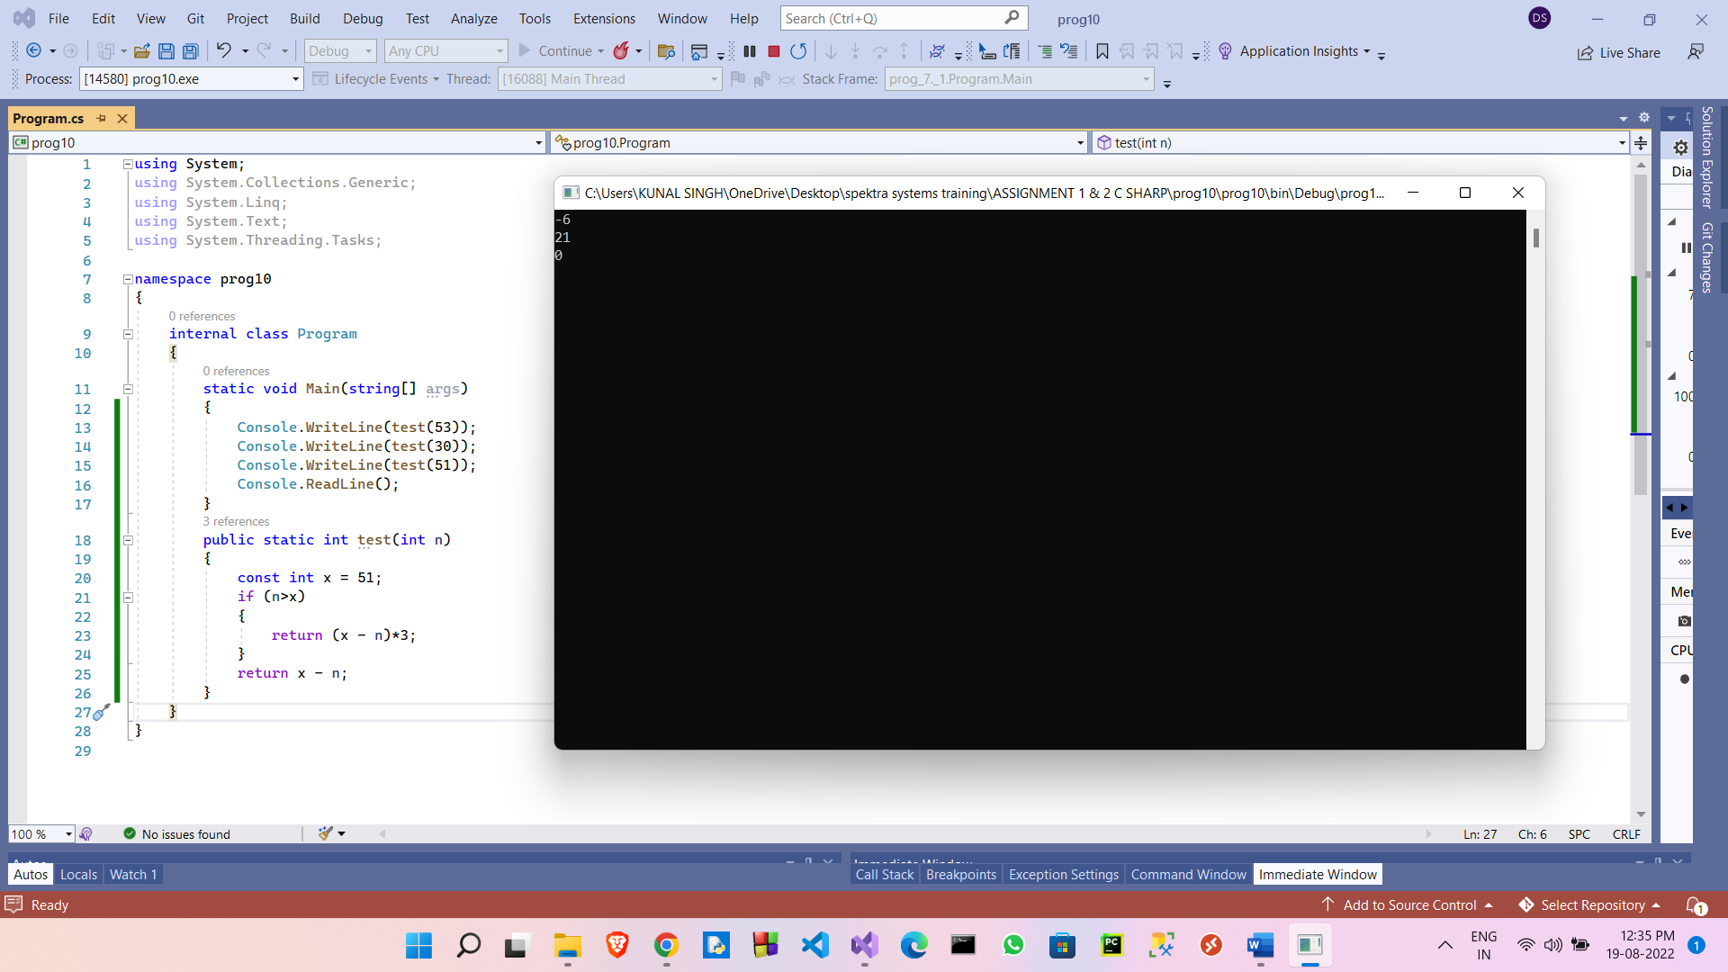

1. Write a C# Sharp program to remove the character in a given position of a given string. The given position will be in the range 0.. string length -1 inclusive.

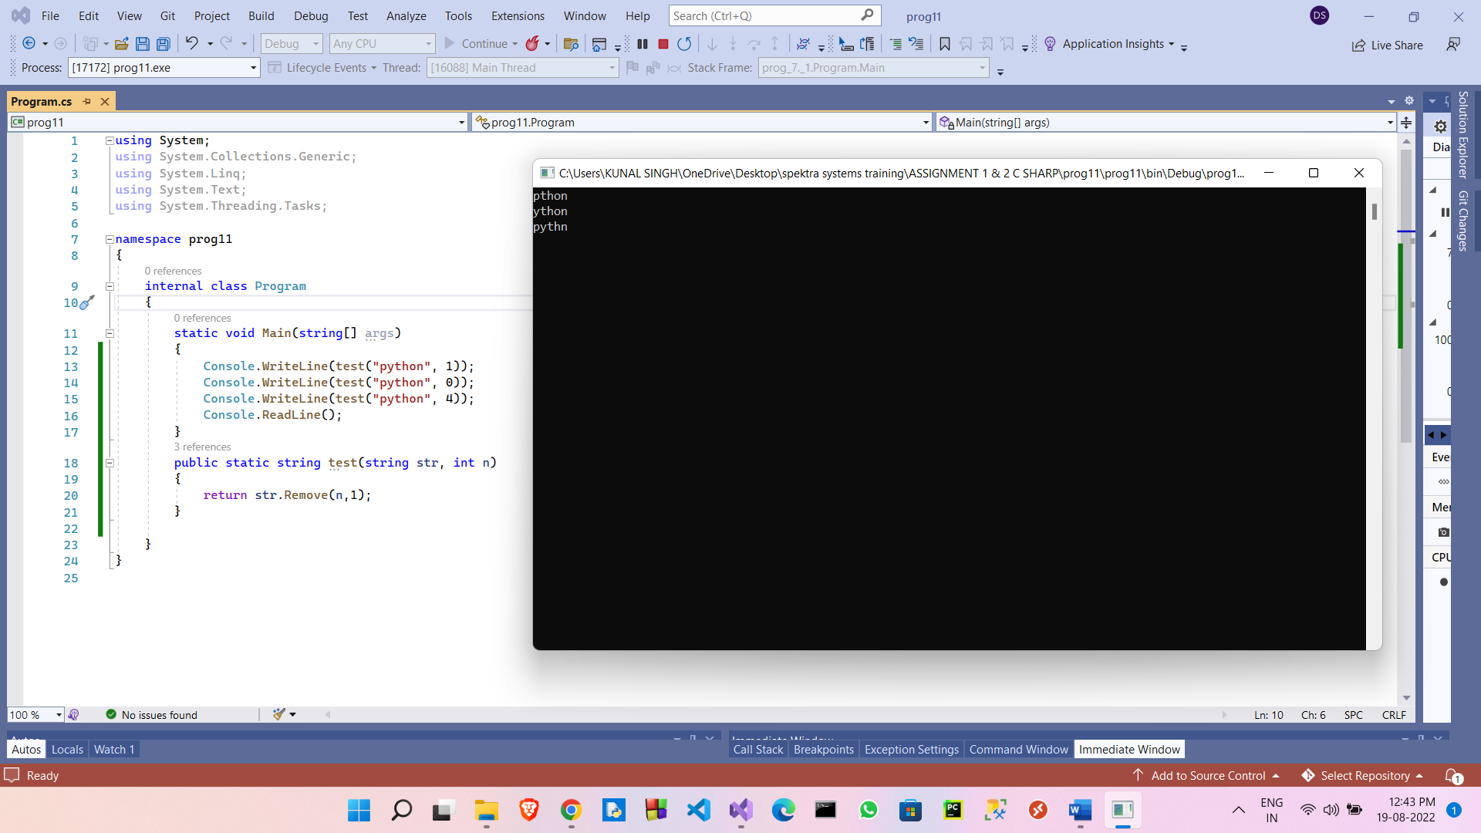

1. Write a C# Sharp program to exchange the first and last characters in a given string and return the new string.

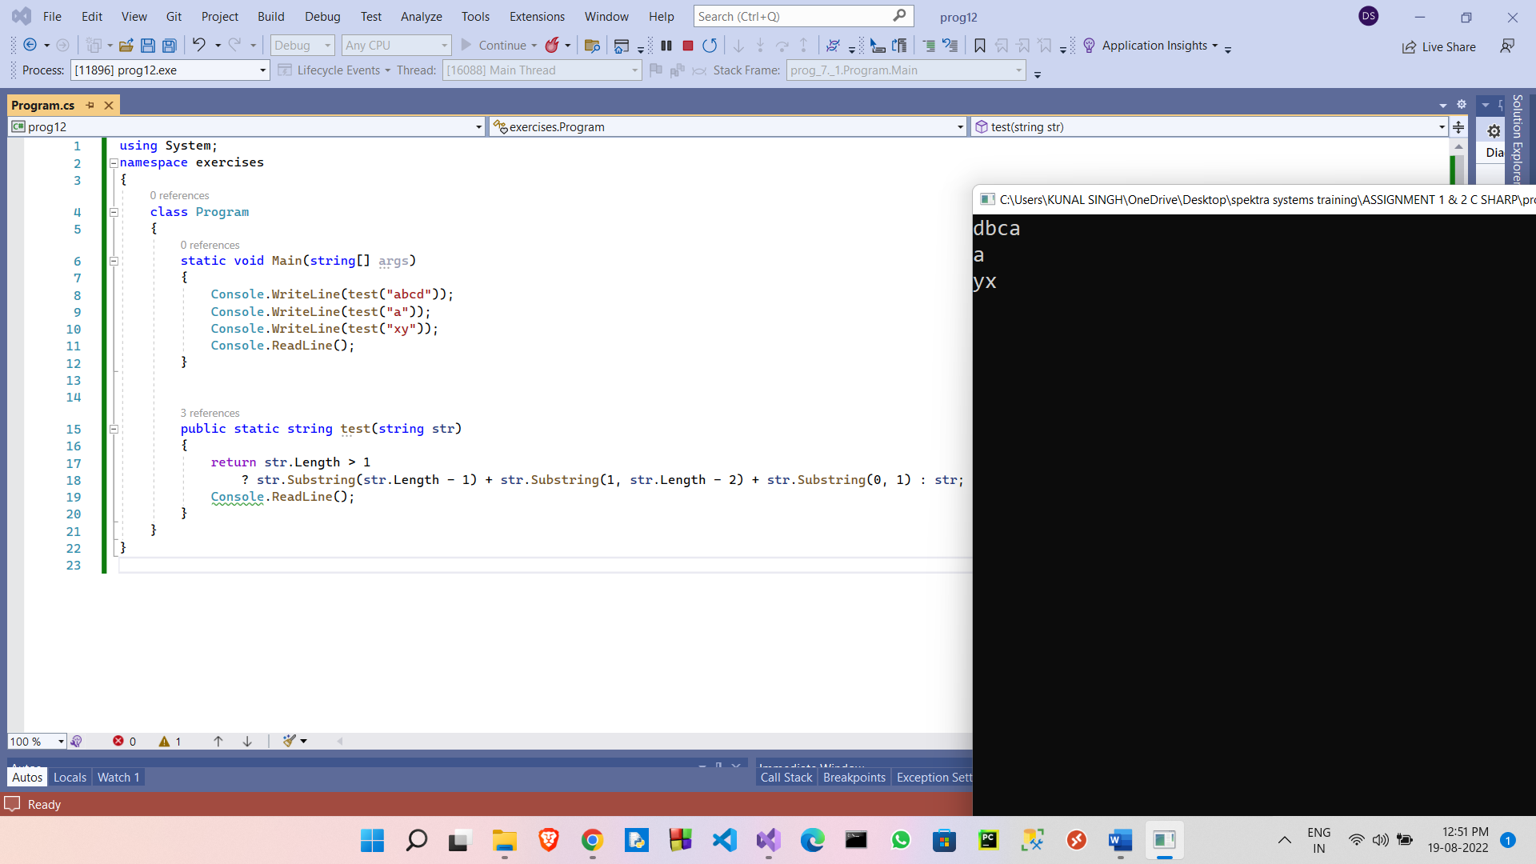

1. . Write a C# Sharp program to create a new array from two give array of integers, each length 3

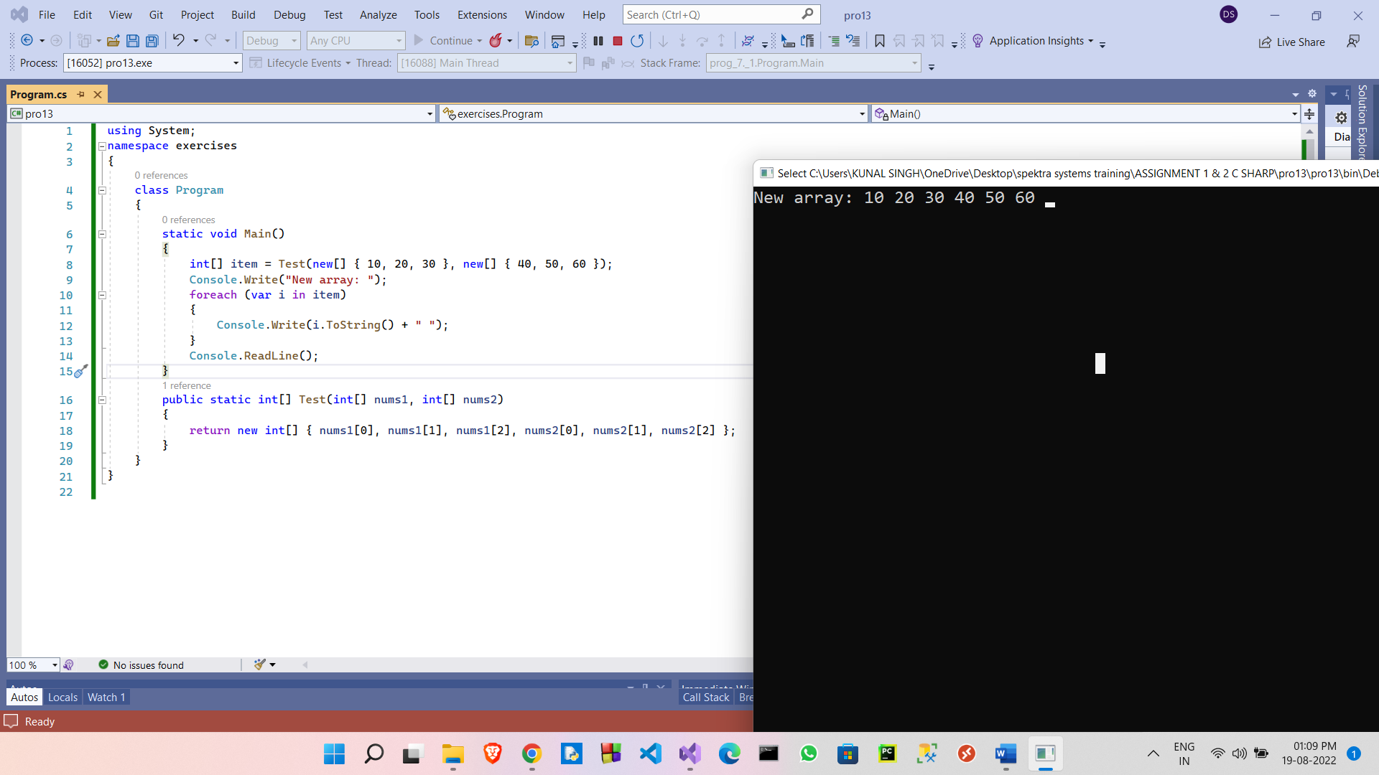

14.Write a C# Sharp program to count the number of strings with given length in given array of strings

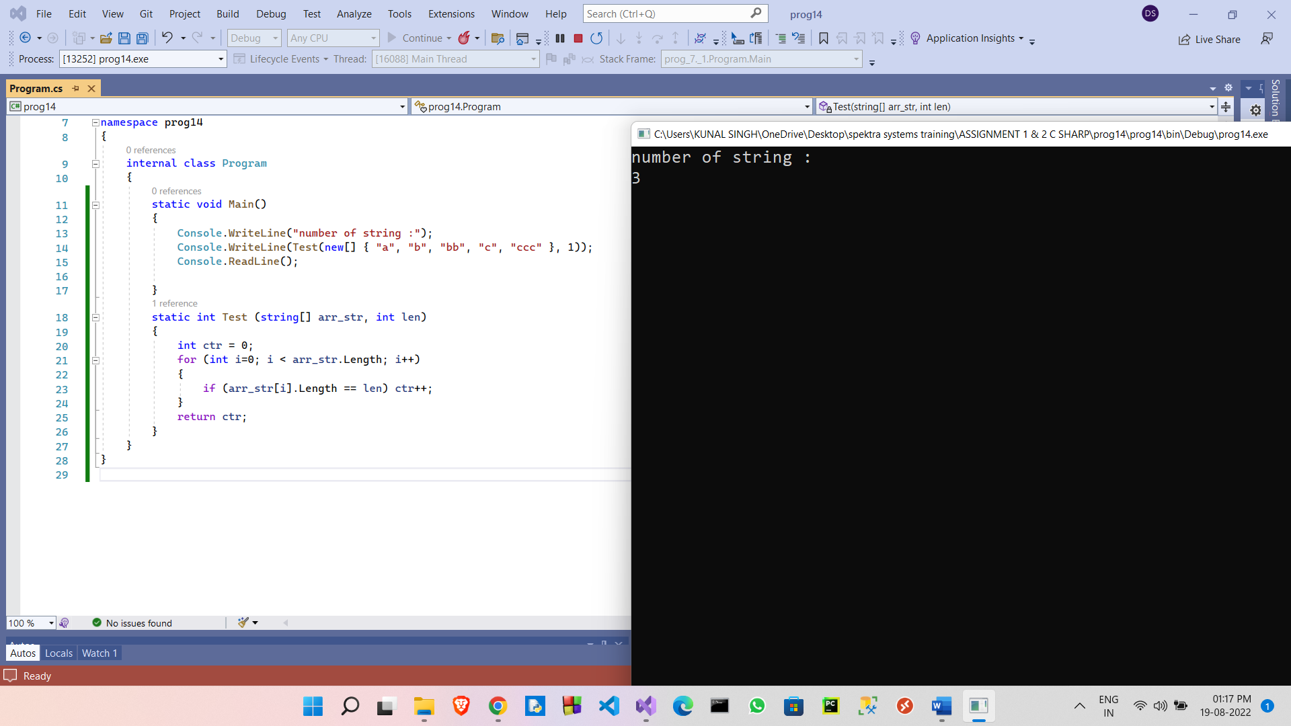

1. Write a C# Sharp program to calculate the value that results from raising 3 to a power ranging from 0 to 32

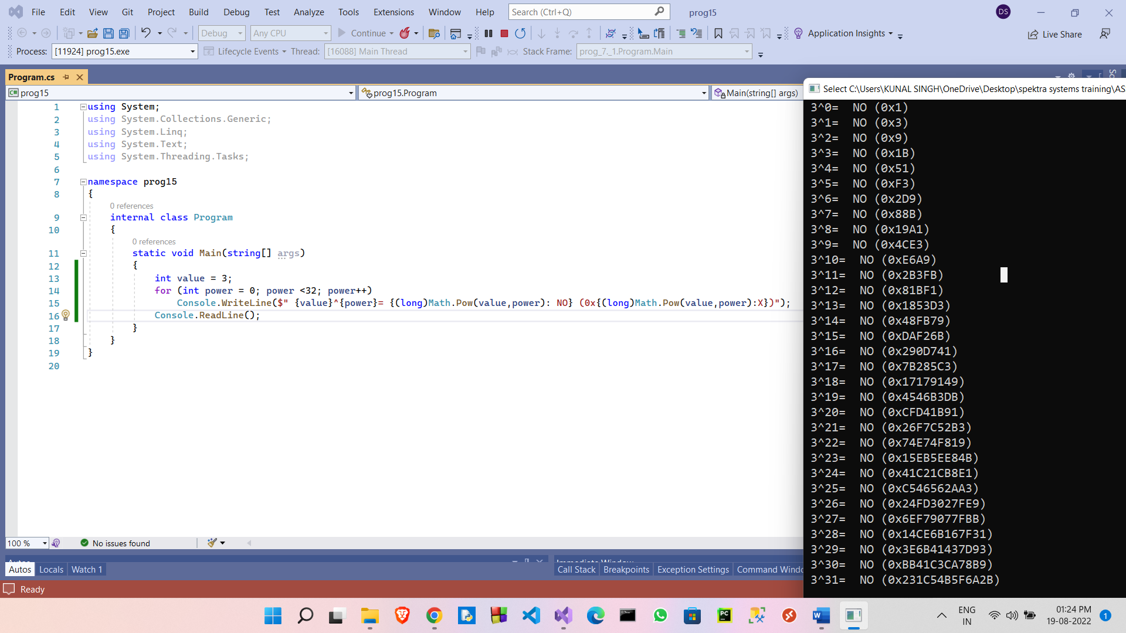

1. Write a C# Sharp program to convert a given integer value to Roman numerals

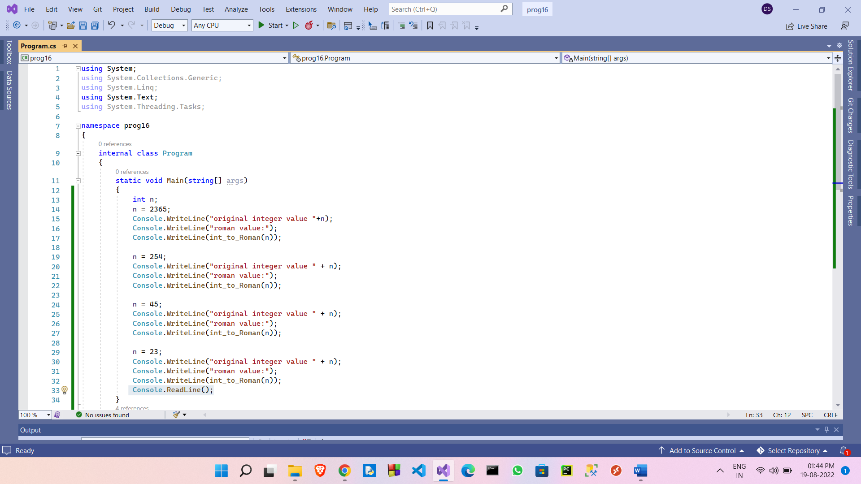

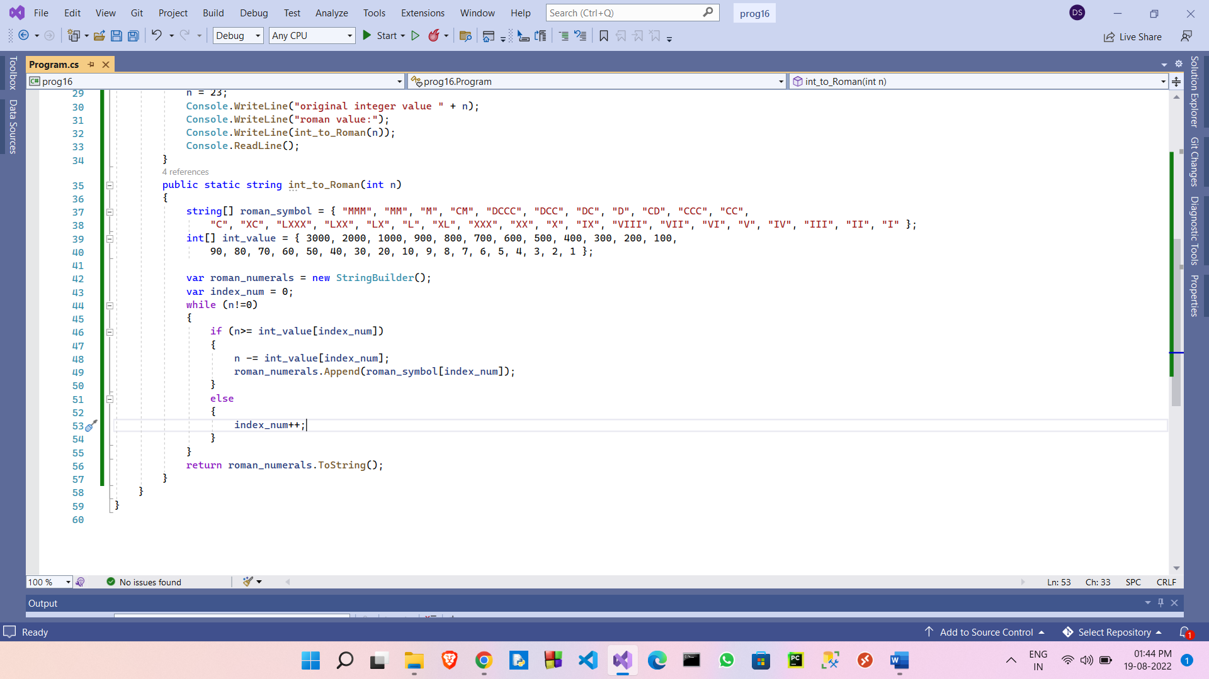

**Output**

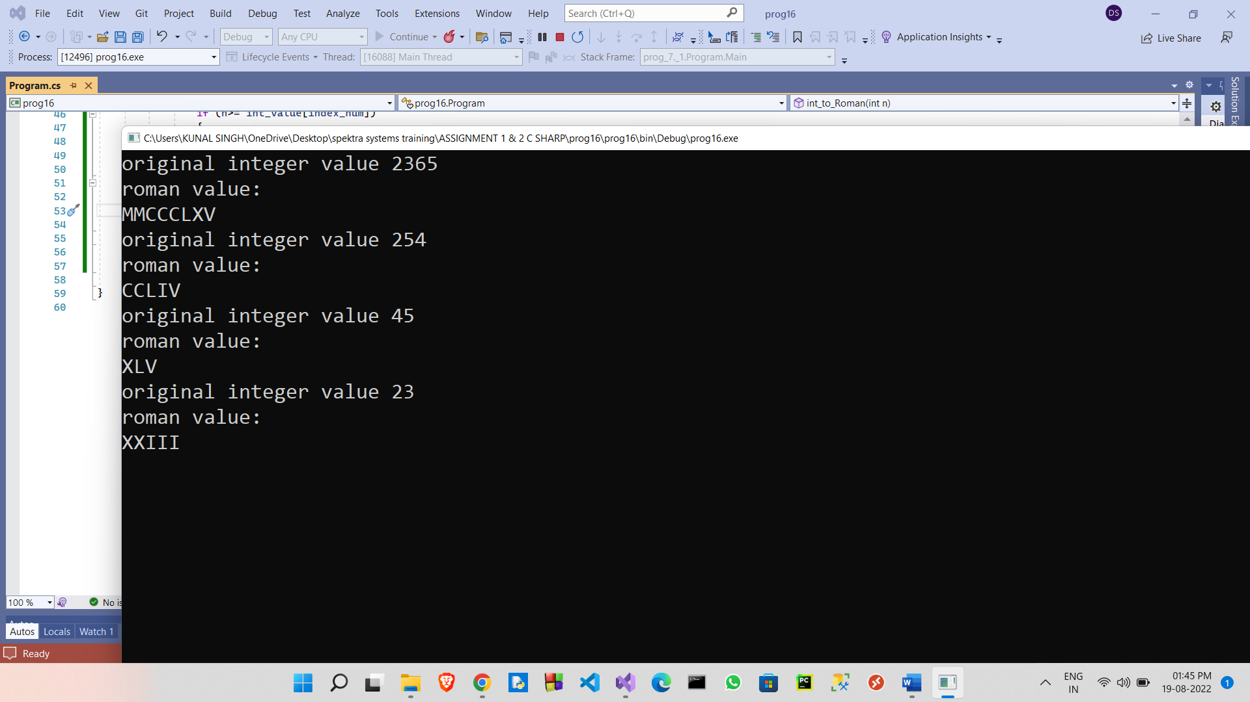

1. Write a program in C# Sharp to find the sum of first n natural numbers using recursion.

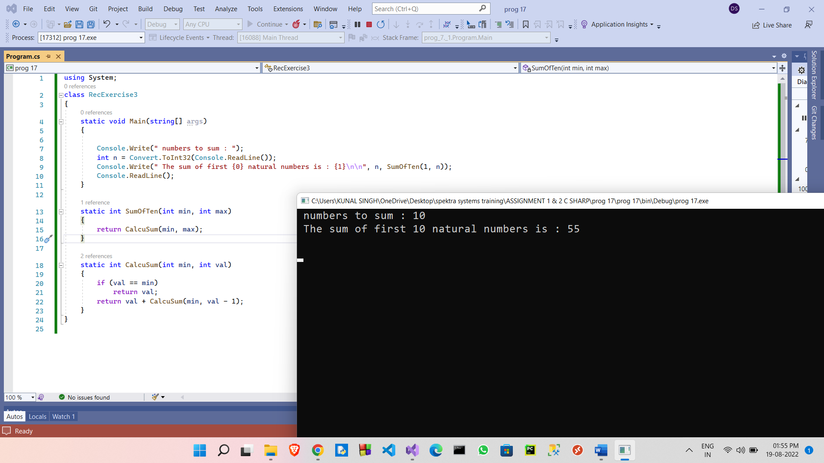

1. . Write a program in C# Sharp to display the individual digits of a given number using recursion

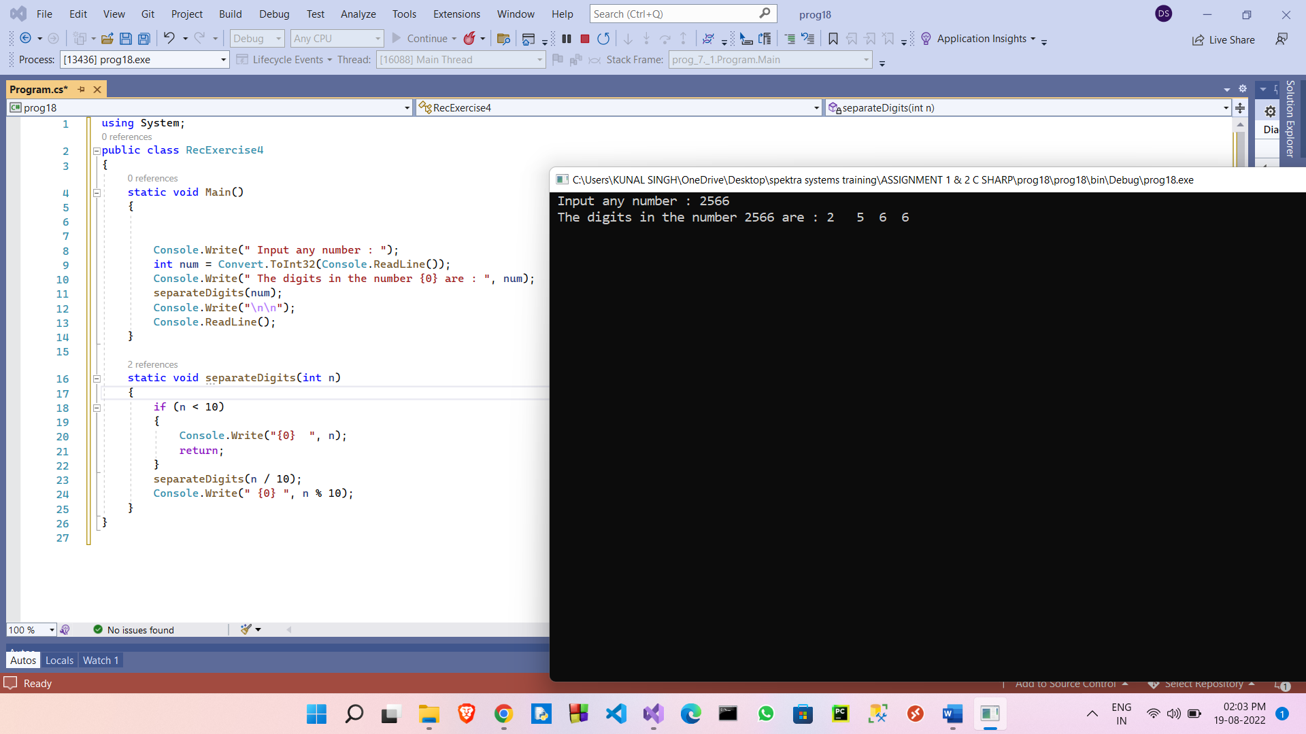

1. . Write a program in C# Sharp to find the number of an array and the square of each number using LINQ

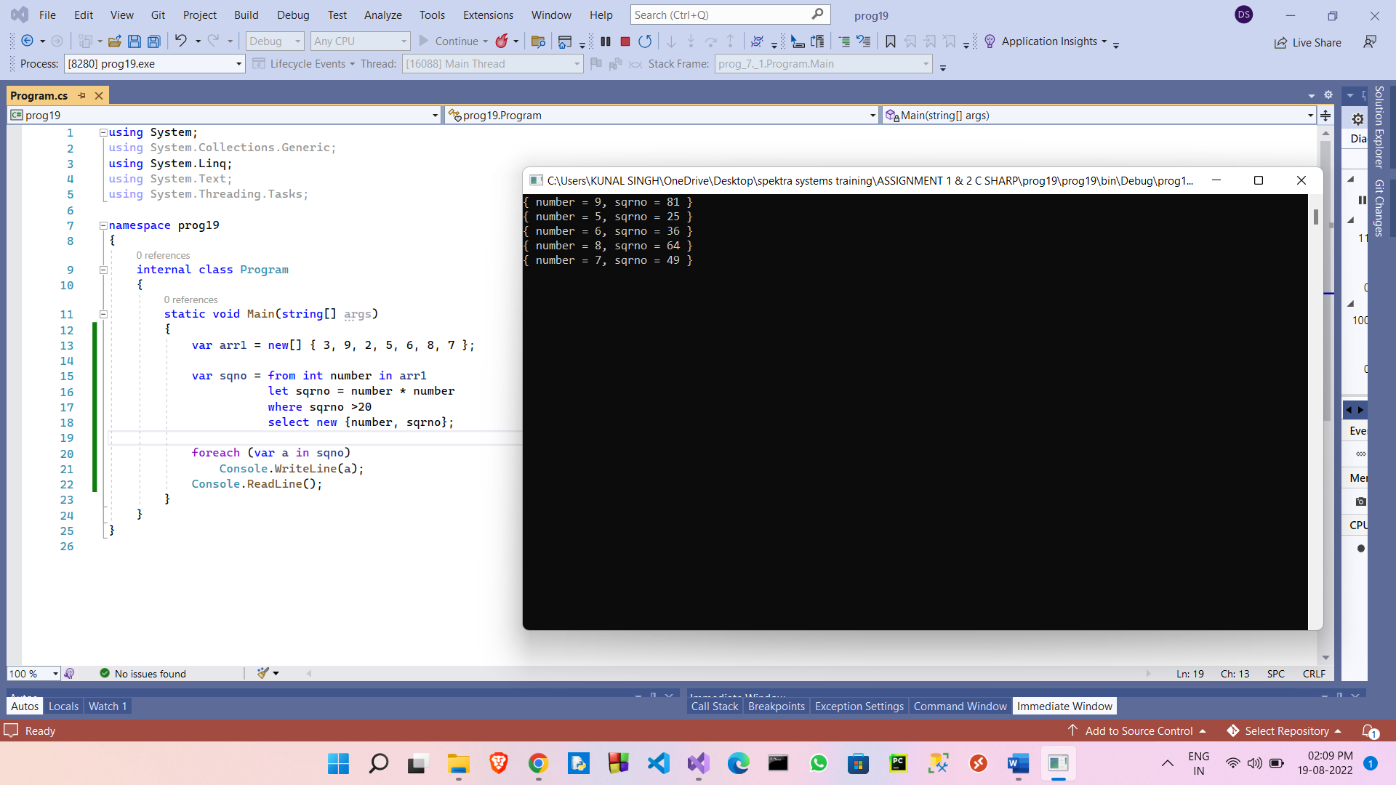

20.Write a program in C# Sharp to display the characters and frequency of character from giving string using LINQ

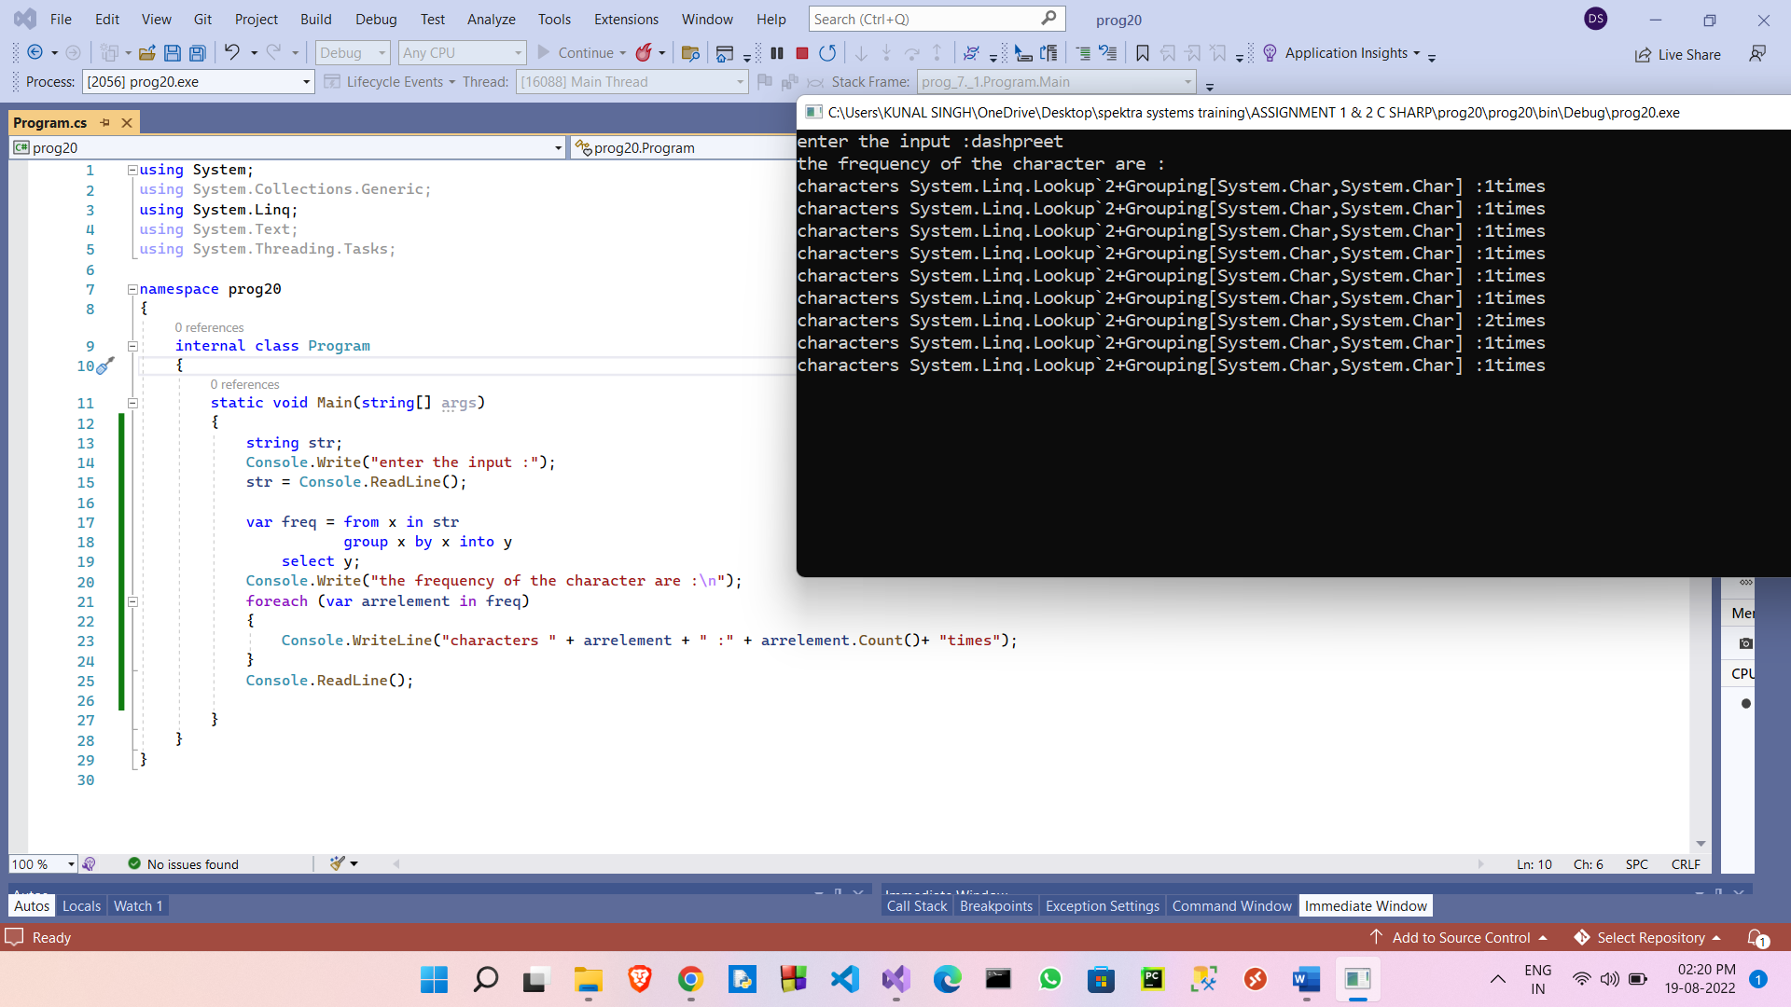

1. Write a program in C# Sharp to find the string which starts and ends with a specific character using LINQ

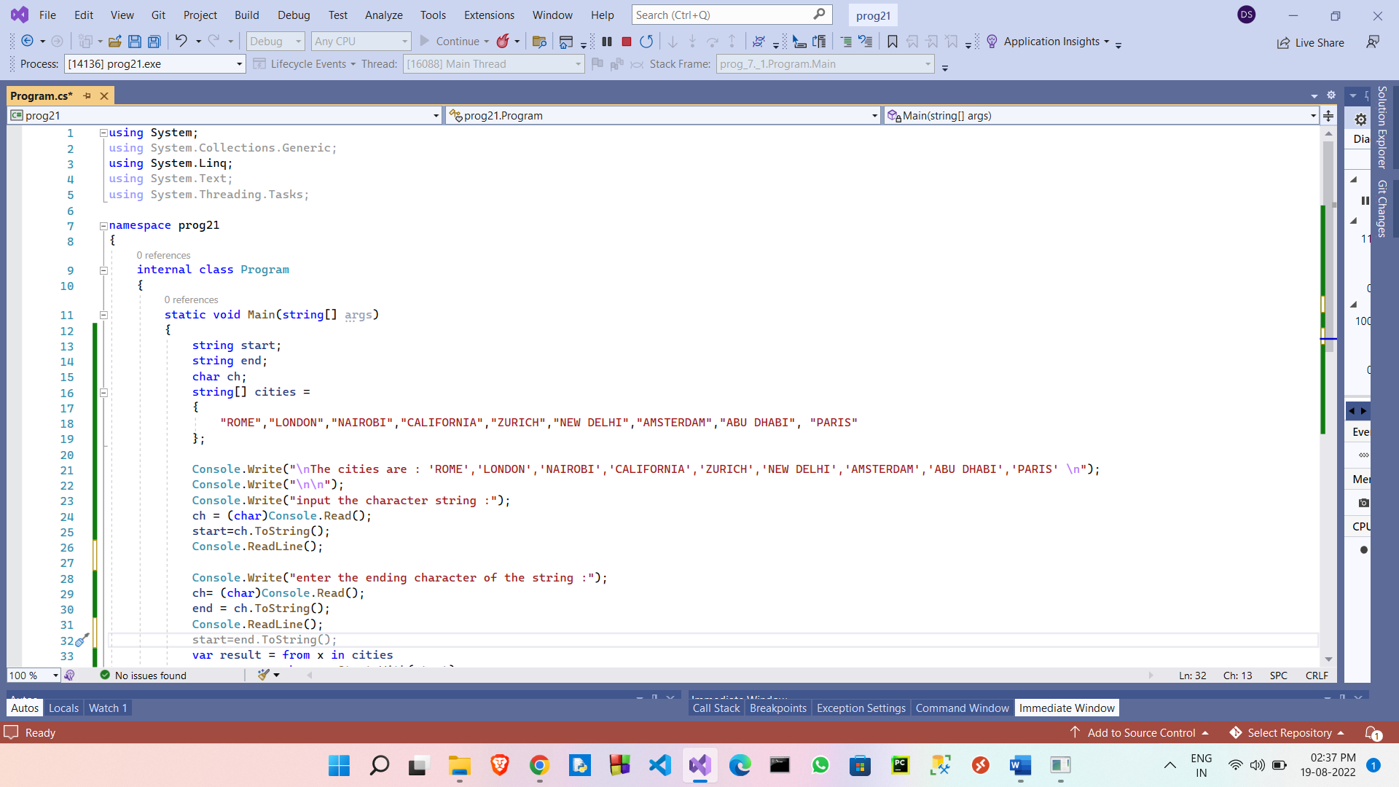

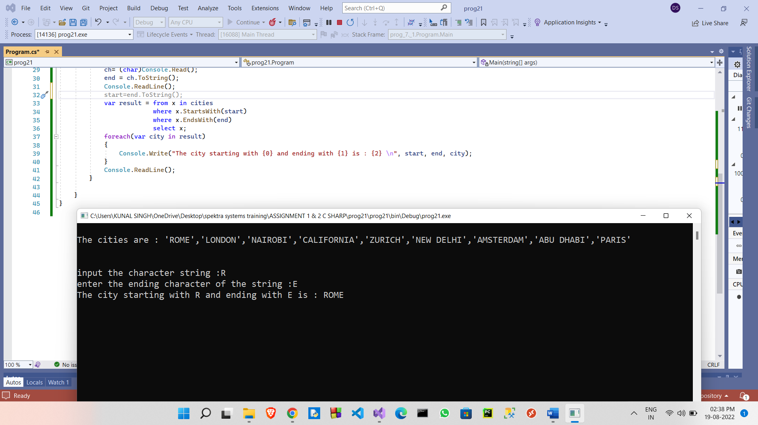

22. Write a program in C# Sharp to display the top n-th records using LINQ

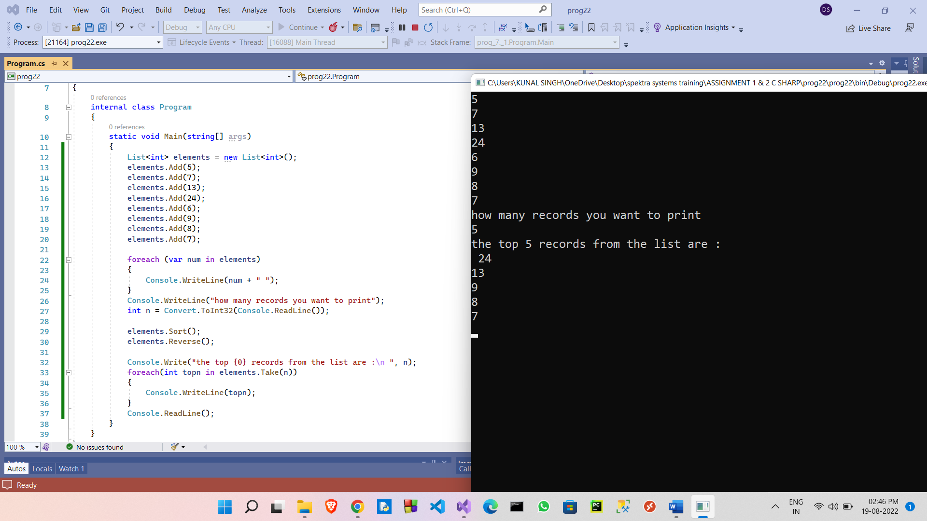

1. Write a program in C# Sharp to count file extensions and group it using LINQ

